4.1 Basic Counting Techniques
Addition Principle: Suppose A and B are finite sets with $A∩B=∅$. Then there are $\left|A\right|+|B|$ ways to choose an element from $A∪B$.
Example: Ray owns five bicycles and three cars. He can get to work using any one of those vehicles. How many different ways can he get to work?
Solution: Since it is impossible to take both a bar and a bike to work, these are disjoint sets. So Ray has 5 + 3 = 8 choices.
Theorem 4.1: Suppose that $A_{1}, A_{2},A_{3},…,A_{n}$ are pairwise disjoint finite sets, that is, $A_{i}∩A_{j}=∅ for all i and j with i≠j$. Then ${|A}_{1}∪A_{2}∪…∪A_{n}|=\left|A_{1}\right|+\left|A_{2}\right|+…+|A_{n}|$.
Multiplication Principle: Let A and B be finite sets. The number of elements (i.e. ordered pairs) in $A×B$ is $\left|A\right|∙|B|$. So there are $\left|A\right|∙|B|$ ways to choose two items in sequence, with the first term coming from A and the second item from B.
Example: Ray owns five bicycles and three cars. He plans to ride a bicycle to and from work, and then take one of his cars to go to a restaurant for dinner. How many different ways can he do this?
Solution: Ray is making two choices in sequence, so he is forming an ordered pair of the form (bicycle, car). Thus there are $3∙5=15$ ways possible.
Theorem 4.2: Suppose that $A_{1}, A_{2},A_{3},…,A_{n}$ are finite sets. Then $\left|A_{1}×A_{2}×…×A_{n}\right|=\left|A_{1}\right|∙\left|A_{2}\right|×…×|A_{n}|$.
Example 1: How many strings of length 3 can be formed from a 26-symbol alphabet?

A string of length three has three characters. For example, ABC or LRC. When choosing the characters for the string, we are making three decisions in sequence, so we use multiplication. The first character can be any of the 26 symbols. The second can also be any of the 26, as is the third. So our calculation is:
$26$ $∙$ $26$ $∙$ $26$ = ${26}^{3}=17,576$ strings.

Example 2: How many designs of the form $□□□$ are possible, if each square must either be red, green, or blue, and no two adjacent squares may be the same color?
We'll use this example to show how a decision tree can be used to answer these questions.
Start with the first decision, and then each branch shows the next choice you can make.
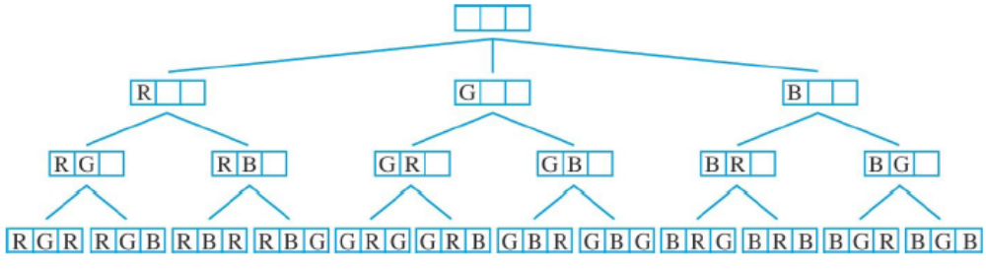
To get our final answer, we simply count the possibilities in the last row. There are 12.
We could also do this problem without a tree, working it similar to example 1.
Our first slot can be any of the THREE colors. The second slot can be either of the TWO colors we didn't choose for the first slot. And the third slot can be either of the TWO colors we didn't choose for the second slot. It's fine to repeat the same color for the first and third slot since they're not adjacent. So the math would be:
$3$ $∙$ $2$ $∙$ $2$ = $12$.

Example 3: How many different strings of length 7 can be formed from a 26-string alphabet, if no two adjacent symbols can be the same?
This would be way too much to make a decision tree for, so we'll just solve it using multiplication. Same idea as the previous problem, just bigger numbers.
$26$ $∙$ $25$ $∙$ $25$ $∙$ $25$ $∙$ $25$ $∙$ $25$ $∙$ $25$ = $26∙{25}^{6}=6,347,656,250$ strings.
Sometimes we will need to use addition AND multiplication in the same problem. It's getting spicy!!!!
We usually have to bring in both operations if there's multiple cases that we have to calculate.

Mixing Addition and Multiplication
Example 4: How many (nonempty) strings of at most length 3 can be formed from a 26-symbol alphabet?
Here there are multiple cases to consider. We need to figure out how many cases exist for "nonempty strings of at most length 3". That means the length could be 1, 2 or 3 characters long. So we'll calculate the answer for each case separately and then add them up.
Length 1: 26
Length 2: $26∙26={26}^{2}=676$
Length 3: $26∙26∙26={26}^{3}=17,576$
Solution: $26+676+17,576=18,278$ strings

Example 5: Using the four colors red, green, blue, and violet, how many different ways are there to color the vertices of the graph (drawn in class) so that no two adjacent vertices have the same color?
The complicated graph I mention in the lecture looks like this:
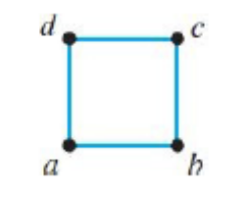
It's a square. It would have been kind of funny in person that the complicated graph was just a square. But now we live in the end-times. So let's just keep moving.
If we start coloring at vertex a, it can be any of the 4 colors. Then vertex b could be any of the 3 remaining colors. This is where the problem gets more complicated. Since vertex c is connected to both b and d, we have to take both of them into account because b and d might match, which would affect what c can be. So we break it up into two cases:
CASE 1: B and D match.
CASE 2: B and D do not match.
For Case 1: We know A can be any of 4, and B can be any of the remaining 3. Since B and D match in this case, D can only have 1 choice. (Whichever color we already chose for B.) Now C has 3 options. (The only color it can't choose is the color of B and D.) So the answer for this case is $4∙3∙3∙1=36$
For Case 2: We know A can be any of 4, and B can be any of the remaining 3. Since B and D don't match, we know D cannot be the color for B AND we know D cannot be the color for A, since they're connected. So D has 2 options to choose from. Lastly, C has 2 choices. (It can't be B's color or D's color). So the answer for this case is $4∙3∙2∙2=48$
Adding them together gets our final answer: $36+48=84$

HOMEWORK: #1-6, 9, 11-12, 15, 17-19

